PC to PC – Message Send Module (Auto Send)
The Auto Send Module is used to periodically send messages to Fortna Plus Nodes using the table configurations defined in the Machine Menu and the MsgMap Menu. The function is called for each iteration of the CTRL process.

Message – int, Popup to the MsgMap Menu, select the message map entry that will be activated with a send message function call.
Depth – int, Enter the row number of the table defined by the Menu_Name column of the Message Map entry.
Period – int, The function will send a message each time the Count matches the number entered into the Period.
Count – int, The number of process iterations since the last message was sent.
Now – int, If the Now column is set the message will be sent immediately and the Count will be reset.

PC to PC - Message Request Module
The Message Request Module is configured to Run by adding an entry to the Batches Menu. The function selected for the SERV process is called “Msg Request”. The module is configured by adding entries to the RequestList Menu.

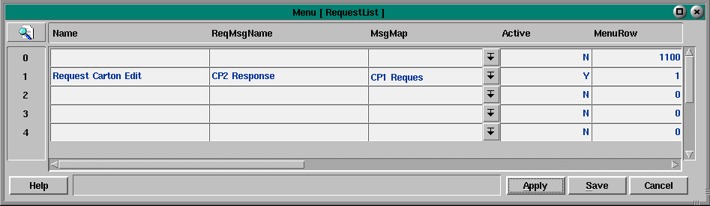

The RequestList Menu triggers messages to be sent by activating messages from the MessageMap Menu. If a message in the Message Map menu has the Menu name “RequestList” entered into the “Menu_Name” field and the protocol is defined as “SortPlus” the system will search the RequestList Menu for an entry linked to the MsgMap row selected. This special type of message will be sent to the corresponding QNX machine and will trigger a corresponding message on the destination QNX PC.

Example Request Message

QNX PC - CP1
QNX PC - CP2
Machine Menu
Machine_Name: CP2
Connection_Type: C_QNX
Protocol: P_SORTPLUS
MsgMap
Menu_Name: RequestList
RequestList
ReqMsgName: CP1 Response
Machine Menu
Machine_Name: CP1
Connection_Type: C_QNX
Protocol: P_SORTPLUS
MsgMap
Name: CP1 Response
Menu_Name:HistData

In the example shown, CP1 has a message map entry that requests CP2 to send the HistData menu to CP1. The RequestList entry contains the name of the Message Map entry on CP2. If the entry in RequestList is Active and the time interval is entered, CP1 will send message requests to CP2 and CP2 will update the HistData table in CP1.

Application code on CP1 may be written to set the Active flag whenever the operator displays the HistData menu or clears the Active flag whenever the operator exits from the HistData menu.

In addition, application code (coupled with menu selections) may be written to set different Active flags (requesting data from different CPU’s) if multiple PC’s have HistData menus with different data.

Request Menu Fields
Name – Description of the entry.

ReqMsgName – Name of the MsgMap entry in the destination PC where this message is being sent.

MsgMap – Message Map entry in this machine that will be sent.

Active – The flag that enables this message.

MenuRow – The menu row to read from the destination PC (if the Low_Cursor and High_Cursor are not equal). The P_SORTPLUS protocol supports (2) types of menu write operations. If the Low_Cursor and High_Cursor are equal (and the row is set to -1), the entire column is sent. If the Low_Cursor and High_Cursor are not equal, the row is sent based on the starting and ending column defined.

SndError – Indicates if an error is detected by the RequestList processing software.
Errors
1100 – Message is not active
1200 – MsgMap index out of range
1300 – How Often field is (0)
1400 – Send Message call returned (0)

HowOften - Enter the Number of increments (based on the Increment). Must be non zero to send a message.

Increment - Enter the Increment (hour, min, sec etc.)

Type - Enter the Type of increment (absolute, elapsed, count, one shot).

CurrentStat - Used by the software to record increments.

WasStat - Used by the software to store time increment data.

SndMsgCtr – Used by the software to count messages sent.

LastMsg – Used by the software to record the last message sent.

Request List Example:
In the following example CP2 is configured to request data from CP1. The Request Message in CP2 (ReqMsgName Column) contains the name of the Message in CP1 that will be triggered to send data to CP2.

MsgMap Menu – CP2
MessageName | MachineName | MenuName | LowCursor | HighCursor
Request FIFO | CP1 | RequestList | 1 | 1

Note: The Menu Name column is set to RequestList, this indicates to the system that a special request message is required for this MsgMap entry.

RequestList Menu – CP2
Name | ReqMsgName | MsgMap | Active | Menu Row | HowOften | Increment | Type
BufferFIFO | Send FIFO Col 1 | Request FIFO | Y | -1 | 1 | INVALID | COUNT

Note: The Menu Row is set to (-1) to request a column of data.

MsgMap Menu – CP1
MessageName | MachineName | MenuName | LowCursor | HighCursor
Send FIFO Col 1 | CP2 | BufferFIFO | 1 | 1

